**Sexually dimorphic blue bands are intra-sexual aposematic signals in non-territorial damselflies**

Md Kawsar Khan1*, Marie E. Herberstein1

1. Department of Biological Science, Macquarie University, NSW-2109, Australia

**Author of correspondence:**

Md Kawsar Khan

Department of Biological Science

Macquarie University, Sydney

NSW-2109, Australia

Email: [Kawsar.khan@mq.edu.au](mailto:Kawsar.khan@mq.edu.au)

Phone: +612-9850-6279

Key words: Insect communication and signaling, Ornamental colouration, Sexual conflict, Sexual selection, Visual modelling, Warning signal

Summary

1. Sexually dimorphic traits in males are thought to evolve via female preference. Alternatively, in species without overt male displays or female mate choice, dimorphic colouration may function as a warning signal to conspecific males thereby avoiding costly harassment. We aim to determine the function of sexual dimorphic coloration in *Xanthagrion erythroneurum* damselflies where males, but not females carry conspicuous blue bands on the tip of the abdomen.
2. The male blue bands and female black abdomen are chromatically and achromatically discriminable in the damselfly visual system. The male blue bands generate higher chromatic contrast than female abdominal coloration against the natural vegetation in their habitat.
3. We abolished male blue bands by painting them black and measured female preference between the manipulated and the control males. We did not find any difference in mating success between the control and manipulated males. We therefore rejected the female preference hypothesis for the function of blue bands in this damselfly.
4. To test whether the blue bands function as a warning signal, we manipulated the females by painting male-like blue bands on their abdominal segments and measured the male reaction to those females relative to control females. Females with artificial blue bands on the terminal abdomen were mated less frequently than control females. However, when we painted blue bands on the anterior abdominal segments the males did not discriminate between control and painted females.
5. We conclude that the blue bands in the male damselflies are not an inter-sexual signal to attract females but rather it functions as an aposematic signal towards other males thereby avoiding intra-sexual harassment.

Introduction:

According to the sexual selection theory, conspicuous male colouration in animals can evolve if they improve attractiveness to females or increase success in male-male competition or both (Darwin, 1888). In sexually dimorphic colouration, also known as ornamental colouration, females prefer mating with males that display more conspicuous ornaments during courtship as the colouration is associated with male quality such as physiological conditions (body mass (Contreras-Garduño, Buzatto, Serrano-Meneses, Nájera-Cordero, & Córdoba-Aguilar 2008), body size (Serrano-Meneses, Córdoba-Aguilar, Méndez, Layen, & Székely 2007), immunity (Córdoba-Aguilar, 2002; Weaver, Santos, Tucker, Wilson, & Hill 2018), and sperm quality (Fukuda & Karino 2014), better territory defending capabilities (Córdoba-Aguilar, 2002) or higher social status (Bergman, Ho, & Beehner 2009). Alternatively, in species where males do not exhibit courtship displays, male-limited dimorphic colouration can still evolve as an intra-sexual signal irrespective of female preferences. In this case, male colouration can signal male competitive ability, thereby avoiding unnecessary fights (Olsson, 1994) or it signals unprofitability as a mate, reducing unwanted mating encounters from other males (Beatty, Andrés, & Sherratt 2015).

Sexually dimorphic blue bands are commonly found in many damselflies of the Coenagrionidae family. In these damselflies, males neither maintain territories, nor do they perform courtship displays (Corbet, 1999). Mate searching males hover around the breeding ponds looking for a mating partner, and the scenario resembles a scramble competition among males (Herberstein, Painting, & Holwell 2017). After encountering a female, the male approaches from behind and grasps the female from above to form a tandem. As a consequences, the females cannot see the colour of an approaching male. Thus, females seem to have limited choice over whether or not they mate or with whom, making inter-sexual selection an unlikely mechanism to drive male-limited colour dimorphism. Sherratt and Forbes (2001) proposed that conspicuous male colouration in these damselflies is not a signal to females, rather it is a warning signal to other males to avoid costly mating harassment (Sherrat & Forbes 2001). Under scramble competition for mates, erroneous male-male mating occurrence is not uncommon (Corbet, 1999; Miller, 1987). In this circumstance, male-limited conspicuous colouration can evolve to display their unprofitability as a mate to conspecific males.

Fincke (1997), however, argued that females can show mating unwillingness and avoid tandem formation by hiding, flying away, death feigning, abdomen curling and through a wing raise signal (Fincke, 1997). Moreover, even after a tandem formation, the male needs the female’s cooperation to bend her abdomen and form a wheel to receive the sperm. Female can show resistance at this stage by delaying wheel formation or even by dissociating from the wheel. Under these circumstances, the evolution and maintenance of sexual dimorphic male ornamental colouration could be the result of female preferences, an idea that is yet to be tested in damselflies.

In *Xanthagrion erythroneurum* damselflies, adult males have two blue bands on the dorsum of abdominal segments 8 and 9, (S8 and S9) whereas the females do not have these bands (Figure 1a-b). We aim to determine the function of these male-limited blue bands in this damselfly by experimentally testing both the sexual selection hypothesis and the anti-harassment aposematic hypothesis. If the male specific blue bands evolved through female preferences, we predict that mating success of a male with blue bands will be higher than the success of a male without them. On the other hand, if blue bands function as an intra-sexual aposematic signal, the presence of the blue bands will repel approaching males. The best way to experimentally validate this hypothesis is to paint the blue bands on the female’s abdomen and observe the mating decision of the approaching males. We predict that the presence of the blue bands will repel males and thus females bearing blue bands will be avoided, even though males are able to recognize females based on other female cues.

Materials and Methods

Study species

The *Xanthagrion erythoneurum,* commonly known as Red and Blue damselfly,is a medium size damselfly (19–21 mm) of the Coenagrionidae family (Zygoptera: Odonata). This species is widely distributed across all Australian states and commonly found in ponds, marshes and dams (Theischinger & Hawking 2006). The adult male can be easily distinguished from the other Coenagrionidae species by the red colour of their face, thorax, and first two abdominal segments, and by the blue bands on abdominal segments eight (S8) and nine (S9) (Figure 1a) (Theischinger & Hawking 2006). The females are similar to males however, their abdomen is dorsally black without any blue bands (Figure 1b). In the Sydney region, this species can be seen in flight from September to April and their reproductive season lasts throughout this whole period (per observation).

We collected adult male and female *X. erythroneurum* damselflies using an insect sweep net from the lake situated in the North Ryde campus of Macquarie University, NSW, Australia. Permission was not required to collect this damselfly species because it is not protected in Australia and studies were conducted outside of any national park or protected area.

Reflectance spectra

We measured the reflectance spectra of the abdominal blue bands of the males from the segments S8 and S9 and the black colouration of the females in the same segments with a Jazz Ocean optics spectrophotometer (Ocean optics, USA). We set the spectrophotometer at an integration time of 20 milliseconds with an average of five successive scans. We used a PX-2 pulse xenon light source and took the measurements relative to a white standard WS-1. We immobilized the damselflies by restraining them in a refrigerator at 40C for five minutes before taking the spectra. We focused the light source of the spectrophotometer perpendicular to the cuticular surface of the damselflies and measured spectra from a uniform distance of 2mm. We used a black velvet cloth to block light between the probe and the specimen. We measured spectra of the plant leaves from the pond site where the damselflies usually perched to quantify the background spectrum. We measured reflectance spectra of the damselflies and background leaves between 300nm to 700nm averaged from three measurements.

Discriminability

The question we want to address with these spectral measurements is how conspecifics discriminate the male and female specific abdominal colours against natural backgrounds. This type of questions can be addressed by colour discrimination analyses (Kemp et al., 2015).We used a discriminability index (D) to estimate the chromatic discriminability (Ds) of the dorsal coloration of the eighth and ninth abdominal segments of the damselflies (blue in males and black in females) against the natural background based on the index proposed by Hastad Victorsson, & Ödeen (2005):

$Ds=$ $\frac{\overline{{ΔS}_{D}}- \overline{{ΔS}_{B}}}{\sqrt{{ΔS}_{D}}},$

where $\overline{{ΔS}_{D}}$ is the average of the chromatic distance of each damselfly spectrum to the measured background spectra and $\overline{{ΔS}_{B}}$ is the average chromatic distance between each background leaf sample (Hastad, Victorsson, & Ödeen 2005). We used a similar rationale for calculating achromatic discriminability (DL) based on the quantum catches of the green photoreceptor since bees and other insects use this photoreceptor to detect achromatic contrast (Giurfa, Vorobyev, Kevan, & Menzel 1996). The discriminability values (chromatic and achromatic) indicate whether the blue bands of the males or black abdomens of the females are detectable against the natural background ─ a value above zero indicates the signal is visible. Because it is unclear if this species has a tri- or a tetrachromatic visual system we calculated the discriminability for both.

Female preference experiments

We manipulated the colour of the damselflies using non-toxic colour paint (Tim and Tess poster paint). We used black paint (105 carbon black) to hide the blue bands of the male abdomen. For the control males we applied the black paint on the dorsal side of abdominal segment S7. We kept one manipulated and one control male with two females in an insect mating cage (58cm × 32cm × 34cm). We placed the cage close to a natural lake, in the sunlight and observed their sexual interaction from a distance of approximately one meter. We calculated the number of the tandem and wheel formation of control and manipulated males. In cases in which a tandem did not form into a wheel, we calculated the duration of the tandem before the pair dissociated. We also recorded the time taken to attain the wheel from the tandem and the duration of the wheel. A trial was considered successful when a male formed a tandem with a female. If a tandem did not formed within 30 minutes, we recorded it as an unsuccessful trial. The experiment was continued until we reached sixty successful trials. We conducted further analyses based on the data collected from successful trials.

Male choice experiments

We manipulated female colour using non-toxic colour paint (Tim and Tess poster paint). We used 90 peacock blue and 105 carbon black paint for colouring blue and black respectively. We painted two blue bands on females matching the colour and brightness of the male blue bands (Figure 1c). In two separate experiments, we varied the position of the bands ─ in the first, the blue bands were applied in the same position as on the male (segments S8 and S9) but in the second experiment we painted the blue bands on segment 4 (S4). To control for the paint, we applied black paint over the natural black patches on the control females.

We placed four damselflies (two males, one control female and one manipulated female) into an insect mating cage (58cm × 32cm × 34cm) at the edge of a pond and observed their behavioral interactions. We terminated a trial if a male successfully formed a tandem with a female or after 20 minutes if no tandem occurred. For each experiment, we performed 40 successful trials between 10 am and 4 pm when mating usually occurs in the field.

Statistical Analyses

We applied the Shapiro-wilk test to determine the normality and an F test to compare the variance of the data. We used Welch two sample t-tests to compare males and females on their chromatic and achromatic discriminability. To determine whether the female preferences between the males with or without blue bands, we used a chi-square test. We applied the Mann-Whitney U test to compare the duration of tandem formation, and the duration from tandem to wheel formation and two sample t-test to compare the duration of wheel between the control and manipulated males. We applied a chi square test to determine the mating frequency of the control females and manipulated females. We analysed all the data in R v 3.4.1 (2017).

Results

Damselfly spectra

The reflectance spectra of the male blue abdominal bands peaked between 450-481 nm while the female abdominal segments did not show any peaks but a gradual increase with increasing wavelengths (Figure 1c). Like males, manipulated female bands also showed reflectance peaks in this region (471-472nm) (Figure 1c).

Discriminability

Both male abdominal blue bands and female abdominal colouration were chromatically and achromatically discriminable in the trichromatic damselfly visual system against the natural background (Figure 1d-e). The chromatic discriminability of the male blue bands was significantly (p < 0.001) higher than female’s abdominal colouration (Figure 1d). However, no significant difference in discriminability was found between the sexes achromatically (Figure 1e). In case of a tetrachromatic visual system, the dorsal abdominal coloration of both sexes are discriminable against their background ─ males are chromatically more discriminable (p < 0.001) while females are more discriminable achromatically (p < 0.001) (Figure S1a- b).

Female preference

The control males (with blue bands) and manipulated males (without blue bands) do not differ significantly in terms of tandem (χ2 = 0.127, df= 1, p = 0.721) and wheel formation (χ2 = 0.986, df= 1, p = 0.320) (Figures 2a-b). Similarly, there is no significant difference in tandem duration (p = 0.052), the time required from tandem to wheel formation (p = 0.769) and wheel duration between control males and manipulated males (p = 0.934) (Figures 2c-e).

Mate choice assays

When females carried blue bands on abdominal segments S8 and S9 (similar to male colouration) males were significantly less likely to form tandems (χ2 = 9.8, df= 1, p = 0.001) compared with control females (Figure 2a). However, when the females carried the blue bands on abdominal segment S4, the males formed tandems at similar rate with manipulated and control females (χ2 = 0.8, df= 1, p = 0.371) (Figure 2b).

Discussion

We manipulated the male blue bands and observed female preference for mating partners between the manipulated and control males. If the male blue bands are sexually selected ornamental colouration then we predict the males with the blue bands will have greater mating success than the males without blue bands as a result of female’s preference. Our results, however, showed that there were no significant difference in the number of tandems between the control and manipulated males. As males approach from above the female during tandem formation, the females cannot immediately detect male colouration and cannot reject an approaching male on the basis of his colouration. One might argue that in a cage experiment a female cannot fly away from an approaching male and the outcome observed could be due restricted movement. While this is tru for the first stage of mating interactions, females can still reject males and dissociate from the tandem, or can delay the wheel formation. We did not, find any difference in tandem duration, numbers of wheel formation and the duration of wheel formation between the control and manipulated males, suggesting that females do not reject males based on the presence of the blue bands. To the best of our knowledge, our study provides the first experimental evidence showing in damselflies that the females do not express a preference for dimorphic colouration in males. We conclude that, male-limited dimorphic colouration is unlikely to evolve through female preferences.

We found that when females carried blue abdominal bands in the same positions as males, they were less attractive than control females or females that carried blue bands elsewhere on the abdomen. There are two possible interpretations of our observations: either males failed to recognize manipulated females as potential mates or the blue bands acted as a warning signal to males. We argue for the latter interpretation as males had sufficient cues available to identify females. Odonates use tactile and visual cues for mate recognition (Winfrey & Fincke 2017). The female black abdomen is the most important cue for mate recognition (Gorb, 1998). However, males also use body size (Pezalla, 1979), abdomen shape (Gorb, 1998; Ubukata, 1983), flight pattern (Ubukata, 1983), female display (Gorb, 1992; Utzeri, 1988), thorax colouration and pattern (Miller & Fincke 1999; Xu, Cerreta, Schultz, & Fincke 2014) and chemical cues (Frati, Piersanti, Conti, Rebora, & Salerno 2015) for mate recognition. Moreover, Gorb (1998) showed that males can even recognize a female based on isolated female body parts (thorax, head). Hence, we argue that the males in our study could still identify the manipulated females as a conspecific female based on their overall phenotype. However, the presence of the blue bands on the female’s abdomen repelled males and may thus function as a warning signal, possibly indicating an unprofitable mating partner.

To define the conspicuous colouration that displays unprofitability Poulton (1890) used the term “aposematism” (Poulton, 1890). Later on, “aposematism” was typically used in the context of predator-prey interaction where bright, vivid colouration of a prey signals their unpalatability to predators. However, aposematic signals are neither restricted to interspecific communication, nor are their functions limited to predation avoidance. For example, in *Battus phileno* butterflies, the colour pattern of the larva is an intraspecific aposematic signal to repel conspecific females from ovipositing on the same leaves, thereby reducing intraspecific competition (Papaj & Newsom 2005). In damselflies, Sherratt and Forbes (2001) applied the concept of aposematism in a sexual context and suggested the term “antisexual aposematism” to explain the function of conspicuous colouration to avoid unwanted sexual harassment. The hypothesis was later supported in *Nehalennia irene* damselflies, where abdominal blue colouration on males repelled conspecific males (Beatty, Andrés & Sherratt 2015). Our study further solidify this hypothesis by showing that the males avoid mating with females bearing the warning signal even when other female specific cues are present.

Our results showed that the spatial location of the aposematic bands is crucial for their function. Visual signal will function most effectively when presented optimally to the receiver and are thus often restricted to specific body parts that maximize its presentation. For example, the aposematic coloration of the unpalatable poison dart frogs are located on their dorsum, which maximizes its presentation to bird predators (Dreher, Cummings, & Pröhl 2015; Maan & Cummings 2011). Similarly aposematic bands on the upper side of wings of butterfly maximize the color presentation during flight (Joshi, Prakash, & Kunte 2017; Su, Lim, & Kunte 2015). In our study, the painted blue bands on the female’s abdomen were effective to repel males only when present on the dorsal side of the terminal abdominal segments. Considering the mating biology of damselflies where males approach from behind and grab females from the top to form a tandem, the location of the bands seem most appropriate at distal end of the dorsal abdomen. This spatial position also maximizes the presentation of the blue bands during the threat display where a male raise his tail to threatened conspecific males (Utzeri, 1988).

An aposematic colour pattern functions best when the signal generates high contrast against the background and when the pattern possesses high internal contrast (Endler, Krebs, & Davies 1991; Stevens & Ruxton 2012). In *Xanthagrion erythroneurum* damselflies, the warning signal comprises two blue bands separated by black abdominal colouration. The combination of black with a bright colour such as red, yellow or blue generates high internal contrast and considered as classic aposematic colour (Cott, 1940). The blue colour of damselflies further generates high chromatic and achromatic contrast against a natural green background (Figure 1 d; Schultz, Anderson, & Symes 2008). High colour contrast signals enhance the speed and stability of avoidance learning and reduce recognition errors (Gamberale-Stille, 2001).

Theoretically, aposematism benefits both the signaler and the receiver. Male-male interactions can be costly in terms of time, energy and fitness. In *Ischnura ramburii* damselflies male-male mating interactions decrease males’ survival and lower their male body mass (Gering, 2017). In *X. erythroneurum*, the warning signal can help males to avoid male-male tandem formation and thus can be beneficial for both of the receiver and the approaching male. Further studies are needed to understand the cost of the dimorphic bands to males in terms of colour production and potential predation cost due to their conspicuousness. Abdominal blue bands in males are commonly found in many damselfly species (per observation, see also Beatty, Andrés & Sherratt 2015; Gorb, 1998) and thus our findings raise the tantalizing question whether blue abdominal bands function as an aposematic signal across many odonatan taxa.

Authors’ contributions

MKK and MEH conceived the ideas and designed the experiment; MKK conducted the experiment, analyzed the data and wrote the manuscript. Both authors revised and approved the manuscript and are accountable for its content.

Acknowledgements

We thank Ken Chang for discussions and comments on the initial version of the manuscript. MKK was supported by International Macquarie University Research Excellence Scholarship.

Data accessibility

References:

Beatty, C. D., Andrés, J. A., & Sherratt, T. N. (2015). Conspicuous Coloration in Males of the Damselfly *Nehalennia irene* (Zygoptera: Coenagrionidae): Do Males Signal Their Unprofitability to Other Males? *PLOS ONE*, *10*(11), e0142684. https://doi.org/10.1371/journal.pone.0142684

Bergman, T. J., Ho, L., & Beehner, J. C. (2009). Chest Color and Social Status in Male Geladas (*Theropithecus gelada*). *International Journal of Primatology*, *30*(6), 791–806. https://doi.org/10.1007/s10764-009-9374-x

Contreras-Garduño, J., Buzatto, B. A., Serrano-Meneses, M. A., Nájera-Cordero, K., & Córdoba-Aguilar, A. (2008). The size of the red wing spot of the American rubyspot as a heightened condition-dependent ornament. *Behavioral Ecology*, *19*(4), 724–732. https://doi.org/10.1093/beheco/arn026

Corbet, P. S. (1999). *Dragonflies: Behaviour and Ecology of Odonata*. New York: Cornell University Press.

Córdoba-Aguilar, A. (2002). Wing pigmentation in territorial male damselflies, Calopteryx haemorrhoidalis: a possible relation to sexual selection. *Animal Behaviour*, *63*(4), 759–766. https://doi.org/10.1006/anbe.2001.1974

Cott, H. B. (1940). *Adaptive coloration in animals*. Methuen; London.

Darwin, C. (1888). *The descent of man and selection in relation to sex* (Vol. 1). Murray.

Dreher, C. E., Cummings, M. E., & Pröhl, H. (2015). An Analysis of Predator Selection to Affect Aposematic Coloration in a Poison Frog Species. *PLOS ONE*, *10*(6), e0130571. https://doi.org/10.1371/journal.pone.0130571

Endler, B. E., Krebs, J. R., & Davies, N. (1991). Interactions between predators and prey. *Behavioural Ecology: An Evolutionary Approach*, 169–202.

Fincke, O. M. (1997). Conflict resolution in the Odonata: implications for understanding female mating patterns and female choice. *Biological Journal of the Linnean Society*, *60*(2), 201–220.

Frati, F., Piersanti, S., Conti, E., Rebora, M., & Salerno, G. (2015). Scent of a dragonfly: sex recognition in a polymorphic coenagrionid. *PloS One*, *10*(8), e0136697.

Fukuda, S., & Karino, K. (2014). Male red coloration, female mate preference, and sperm longevity in the cyprinid fish Puntius titteya. *Environmental Biology of Fishes*, *97*(11), 1197–1205.

Gamberale-Stille, G. (2001). Benefit by contrast: an experiment with live aposematic prey. *Behavioral Ecology*, *12*(6), 768–772.

Gering, E. J. (2017). Male‐mimicking females increase male‐male interactions, and decrease male survival and condition in a female‐polymorphic damselfly. *Evolution*, *71*(5), 1390–1396. https://doi.org/10.1111/evo.13221

Giurfa, M., Vorobyev, M., Kevan, P., & Menzel, R. (1996). Detection of coloured stimuli by honeybees: minimum visual angles and receptor specific contrasts. *Journal of Comparative Physiology A*, *178*(5), 699–709.

Gorb, S. (1992). An experimental study of the refusal display in the damselfly *Platycnemis pennipes* (Pall.)(Zygoptera: Platycnemididae). *Odonatologica*, *21*(3), 299–307.

Gorb, S. N. (1998). Visual cues in mate recognition by males of the damselfly, *Coenagrion puella* (L.)(Odonata: Coenagrionidae). *Journal of Insect Behavior*, *11*(1), 73–92.

Hastad, O., Victorsson, J., & Ödeen, A. (2005). Differences in color vision make passerines less conspicuous in the eyes of their predators. *Proceedings of the National Academy of Sciences of the United States of America*, *102*(18), 6391–6394.

Herberstein, M. E., Painting, C. J., & Holwell, G. I. (2017). Scramble competition polygyny in terrestrial arthropods. *Advances in the Study of Behavior. 49,* (237-295)

Joshi, J., Prakash, A., & Kunte, K. (2017). Evolutionary Assembly of Communities in Butterfly Mimicry Rings. *The American Naturalist*, *189*(4), E58–E76. https://doi.org/10.1086/690907

Kemp, D. J., Herberstein, M. E., Fleishman, L. J., Endler, J. A., Bennett, A. T., Dyer, A. G., … Whiting, M. J. (2015). An integrative framework for the appraisal of coloration in nature. *The American Naturalist*, *185*(6), 705–724.

Maan, M. E., & Cummings, M. E. (2011). Poison frog colors are honest signals of toxicity, particularly for bird predators. *The American Naturalist*, *179*(1), E1–E14.

Miller, M. N., & Fincke, O. M. (1999). Cues for mate recognition and the effect of prior experience on mate recognition in Enallagma damselflies. *Journal of Insect Behavior*, *12*(6), 801–814.

Miller, P. L. (1987). An examination of the prolonged copulations of *Ischnura elegans* (Vander Linden)(Zygoptera: Coenagrionidae). *Odonatologica*, *16*(1), 37–56.

Olsson, M. (1994). Nuptial coloration in the sand lizard, Lacerta agilis: an intra-sexually selected cue to lighting ability. *Animal Behaviour*, *48*(3), 607–613. https://doi.org/10.1006/anbe.1994.1280

Papaj, D. R., & Newsom, G. M. (2005). A within-species warning function for an aposematic signal. *Proceedings of the Royal Society of London B: Biological Sciences*, *272*(1580), 2519–2523.

Pezalla, V. M. (1979). Behavioral ecology of the dragonfly *Libellula pulchella* Drury (Odonata: Anisoptera). *American Midland Naturalist*, 1–22.

Poulton, E. B. (1890). *The colours of animals: their meaning and use, especially considered in the case of insects*. D. Appleton.

Schultz, T. D., Anderson, C. N., & Symes, L. B. (2008). The conspicuousness of colour cues in male pond damselflies depends on ambient light and visual system. *Animal Behaviour*, *76*(4), 1357–1364.

Serrano-Meneses, M. A., Córdoba-Aguilar, A., Méndez, V., Layen, S. J., & Székely, T. (2007). Sexual size dimorphism in the American rubyspot: male body size predicts male competition and mating success. *Animal Behaviour*, *73*(6), 987–997. https://doi.org/10.1016/j.anbehav.2006.08.012

Sherrat, T. N., & Forbes, M. R. (2001). Sexual differences in coloration of Coenagrionid damselflies (Odonata): a case of intraspecific aposematism. *Animal Behaviour*, *62*, 653–660.

Stevens, M., & Ruxton, G. D. (2012). Linking the evolution and form of warning coloration in nature. *Proceedings of the Royal Society of London B: Biological Sciences*, *279*(1728), 417–426.

Su, S., Lim, M., & Kunte, K. (2015). Prey from the eyes of predators: Color discriminability of aposematic and mimetic butterflies from an avian visual perspective. *Evolution*, *69*(11), 2985–2994. https://doi.org/10.1111/evo.12800

Theischinger, G., & Hawking, J. (2006). *The Complete Field Guide to Dragonflies of Australia*. Csiro Publishing.

Ubukata, H. (1983). An experimental study of sex recognition in *Corduli*a *aenea amurensis* Selys (Anisoptera: Corduliidae). *Odonatologica*, *12*(1), 71–81.

Utzeri, C. (1988). Female” refusal display” versus male” threat display” in Zygoptera: is it a case of intraspecific imitation? *Odonatologica*, *17*(1), 45–54.

Weaver, R. J., Santos, E. S., Tucker, A. M., Wilson, A. E., & Hill, G. E. (2018). Carotenoid metabolism strengthens the link between feather coloration and individual quality. *Nature Communications*, *9*(1), 73.

Winfrey, C., & Fincke, O. M. (2017). Role of visual and non-visual cues in damselfly mate recognition. *International Journal of Odonatology*, *20*(1), 43–52.

Xu, M., Cerreta, A. L., Schultz, T. D., & Fincke, O. M. (2014). Selective use of multiple cues by males reflects a decision rule for sex discrimination in a sexually mimetic damselfly. *Animal Behaviour*, *92*, 9–18.

Figure legends:

Figure 1: Photograph of (a) a male and (b) a female *X. erythroneurum;* (c)aggregated reflectance spectra (mean ± SD) of the male blue bands (N= 20, red line), females abdominal colouration (N = 14, black line), painted blue bands on manipulated females (N= 8, blue line) and background plant leaves (N= 31, green line); (d) chromatic discriminability (Ds) and (e) achromatic discriminability (DL) of male and female abdominal (S8-S9) colouration in the trichromatic damselfly visual system, (* p < 0.05).

Figure 2: (a) number of tandems formed by the control and the manipulated males; (b) number of wheels formed by the control and the manipulated males; (c) duration in tandem formation between the control males and the manipulated males; (d) time required to form a wheel from the tandem between the control males and the manipulated males; (e) duration of wheel formation between the control males and the manipulated males.

Figure 3: (a) the number of control females and S8 and S9 manipulated females (blue bands on segments S8 and S9) and (b) the number of control females and S4 manipulated females (blue bands on segment S4) recorded in mating pairs during the mate choice experiment (N = 40, * p < 0.05).

Figure 1:

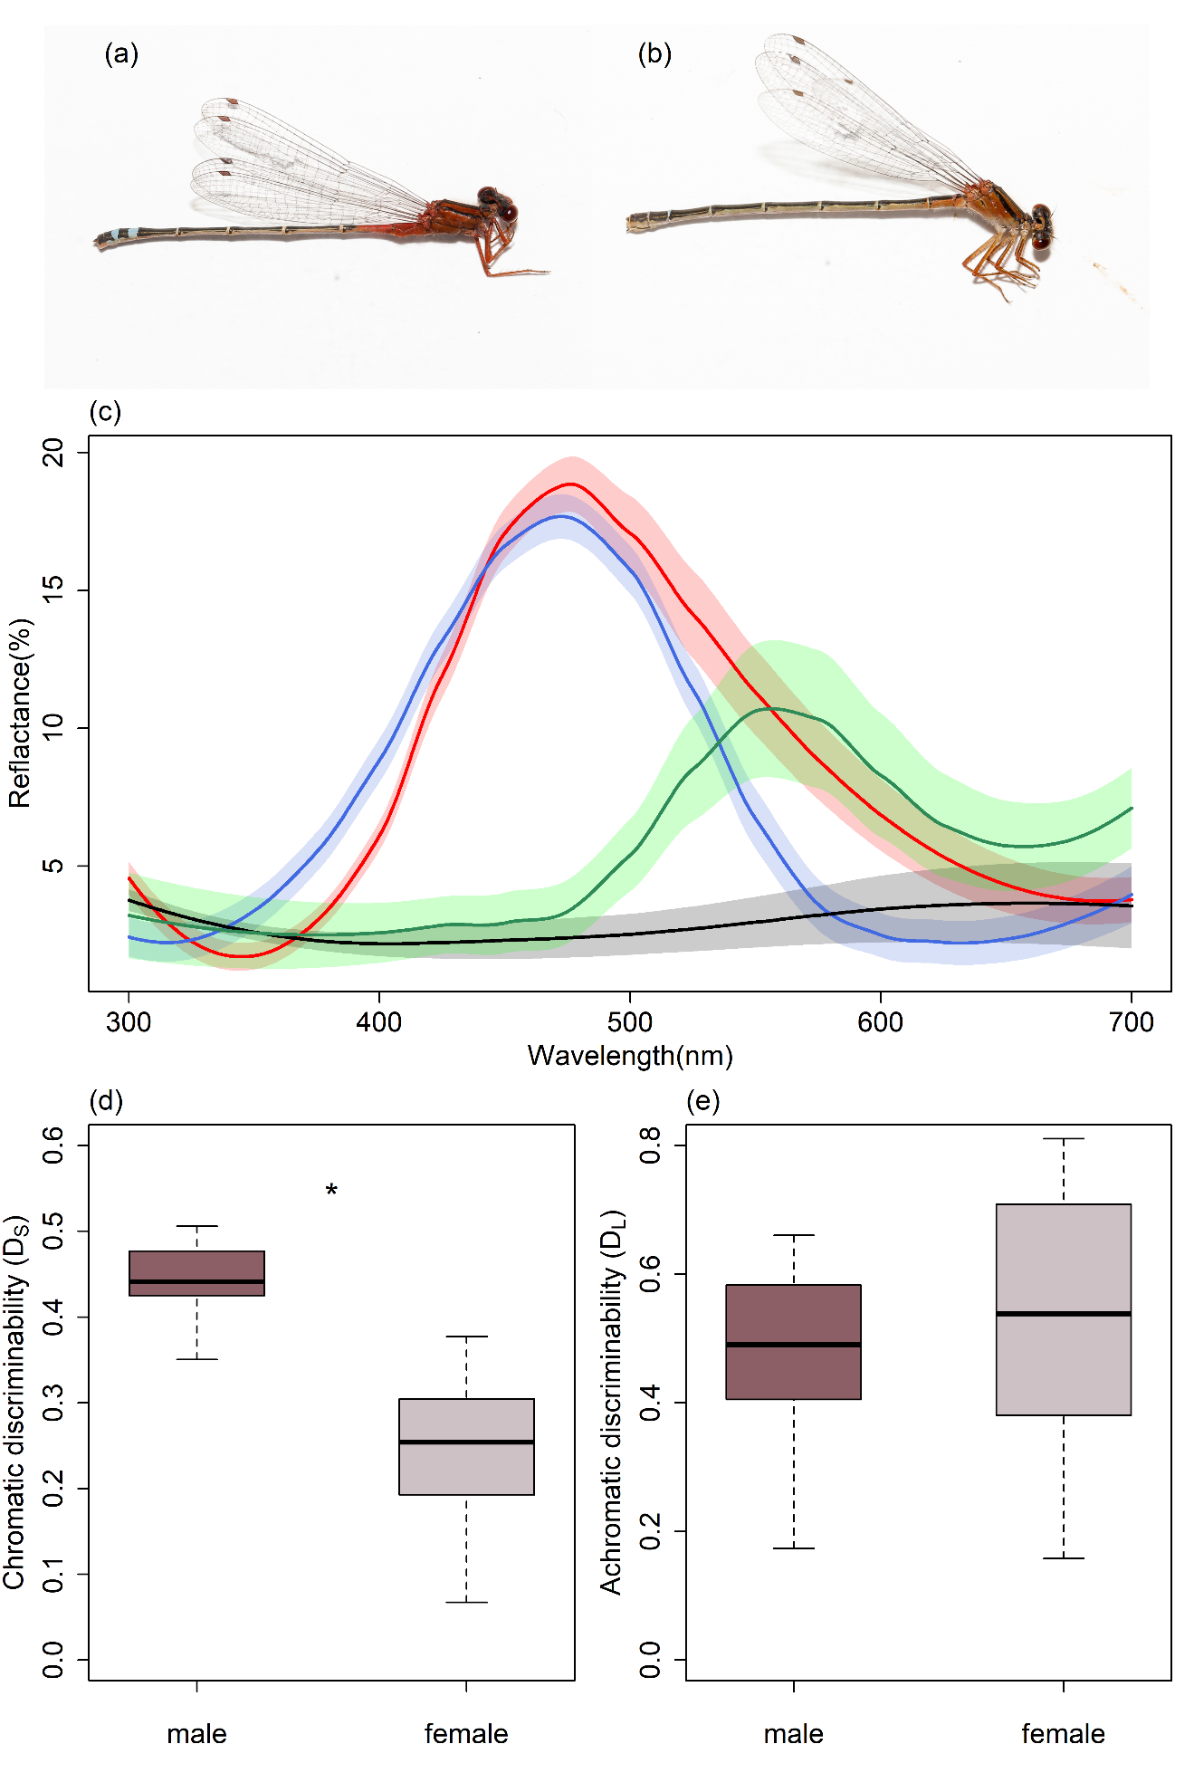

Figure 2:

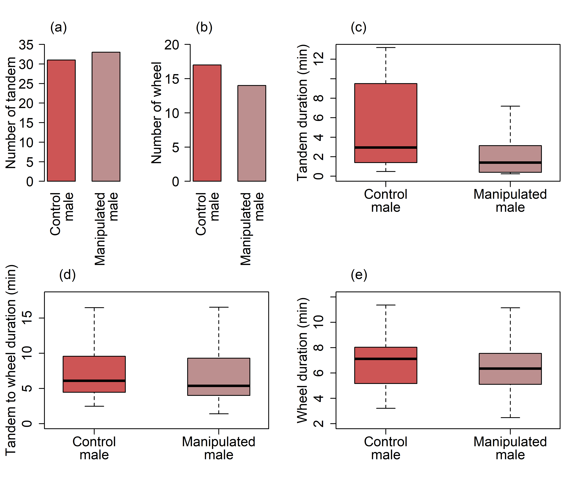

Figure 3:

